Subject: A Message From Starboard: Updates to Starboard Label Requirements
Starboard Group Trading Partner,
Thank you for your continued commitment to meet the EDI requirements of Starboard Group. We would like to inform you of changes we’ve made to the Shipping Label requirements.
Starboard Group is requesting all suppliers to confirm their commitment to following these new guidelines by XX.XX.XXXX. Please send an email with your confirmation to compliance@starboardcruise.com.
Below is a sample image of the updated label requirements, highlighted in red. You can download an excel file of this sample here.
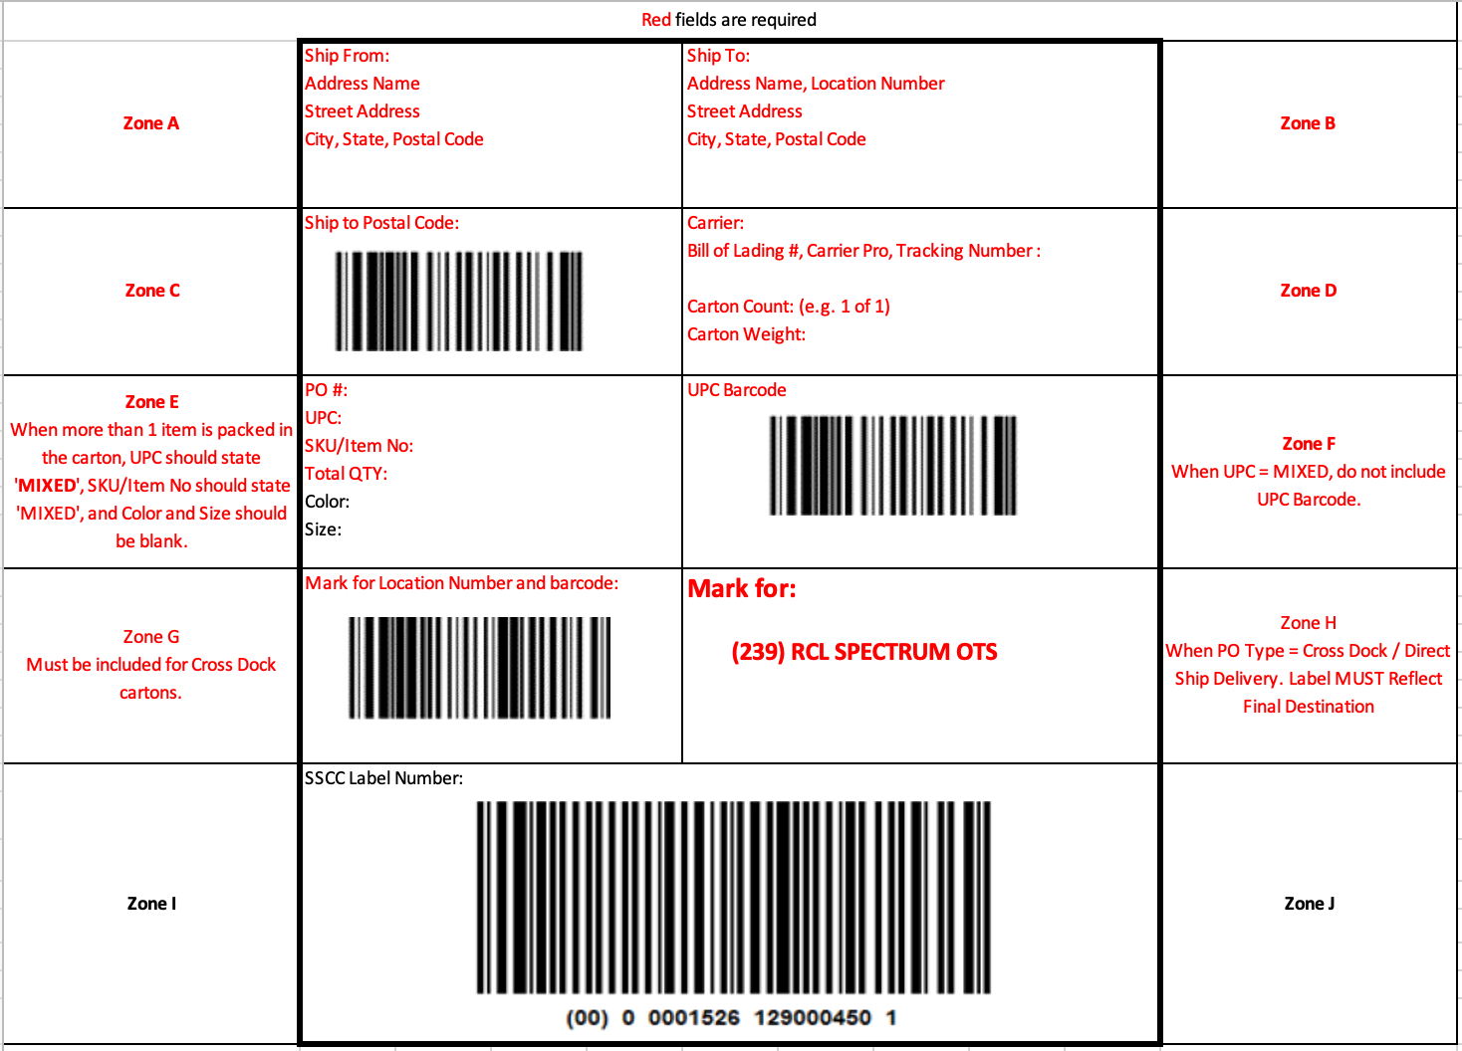

Resources:
For more information on Starboard label requirements, please reference the resources below. You can also reach out to SPS Commerce Support at support@spscommerce.com or 888.739.3232, option 1.

Starboard Vendor Compliance and Routing Manual
Starboard Supplier Wiki Site (EDI Requirements)
Best regards,
Starboard Group

